**Experiment No: 10**

**PATTERN MATCHING ALGORITHM**

Aim: To study and implement pattern matching algorithm.

Theory:

Pattern matching

The Pattern Searching algorithms are sometimes also referred to as String Searching Algorithms and are considered as a part of the String algorithms. These algorithms are useful in the case of searching a string within another string.

The Brute-force pattern matching algorithm or naïve string matching algorithm compares the pattern P with the text T for each possible shift of P relative to T, until either a match is found, or all placements of the pattern have been tried.

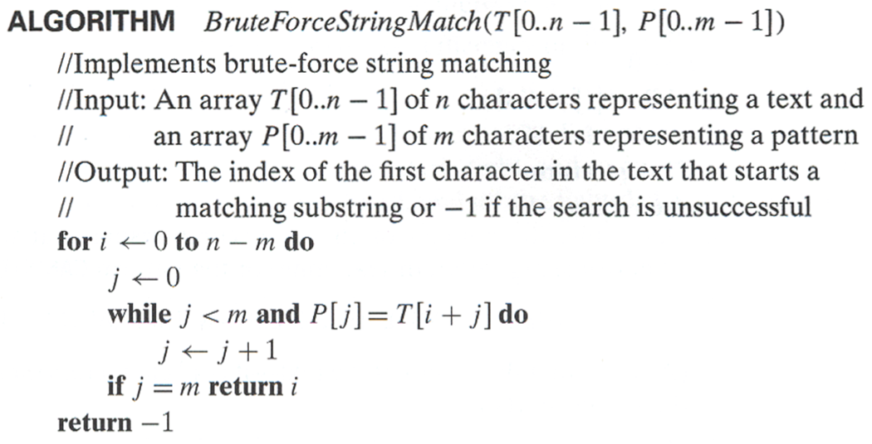

Program and Output:

Conclusion: String Pattern matching algorithm that is Naïve String matching algorithm was studied and implemented successfully.